**Hard To Find Bookshop Database**

**Setup:**

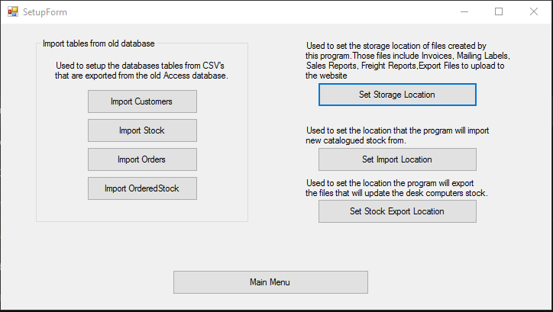

The import buttons on the left side of the screen are used to bring the data from the old Microsoft Access database into the new system. They work by importing through CSV files.

The layout for the customers CSV file is:

CustomerID|FirstName|LastName|Institution|Address1|Address2|Address3|Country|Postcode|Phone|Fax|Email|Comments|Sales|Payment

The layout for the stock CSV file is:

StockID|Quantity|Note|Author|Title|Subtitle|Publisher|Description|Comment|Location|Price|Subject|Catalogues|Weight|Sales|BookID|EnteredBy

The layout for the orders CSV file is:

OrderID|CustomerFirstName|CustomerLastName|Insitution|Postcode|OrderReference|CatItem|Author|Title|Quantity|Price|Progress|DiscPrice|InvoiceNo|InvoiceDate|Comments|StockID|CustomerID

The layout for the orderedstockCSV file is:

OrderedStockID|OrderID|StockID|Quantity|Author|Title|Subtitle|Publisher|Description|Comment|Location|Price|Subject|Catalogues|Weight|Sales|BookID|EnteredBy|Discount

The set storage location button will set the location in which the program will store all of the files that are created by the system. This includes: export files, freight reports, invoices, mailing labels and sales reports. A folder will be created for each file type in the selected location.

Set import location will set the location in which the program updates the stock from. Imported stock should be in a CSV format of:

StockID|Quantity|Note|Author|Title|Subtitle|Publisher|Description|Comment|Location|Price|Subject|Catalogues|Weight|Sales|BookID|EnteredBy

Import location should be set to a Google Drive location for automated transfer between the main system and the store front system. The store fronts system should have the same folder set for it’s export file location.

Set export location is used to set the location to send a CSV file to update the store fronts system. This should be set to a location in Google Drive in a separate folder to the import location. The store fronts system should have it’s import location set to the same folder.

**Customers Screen:**

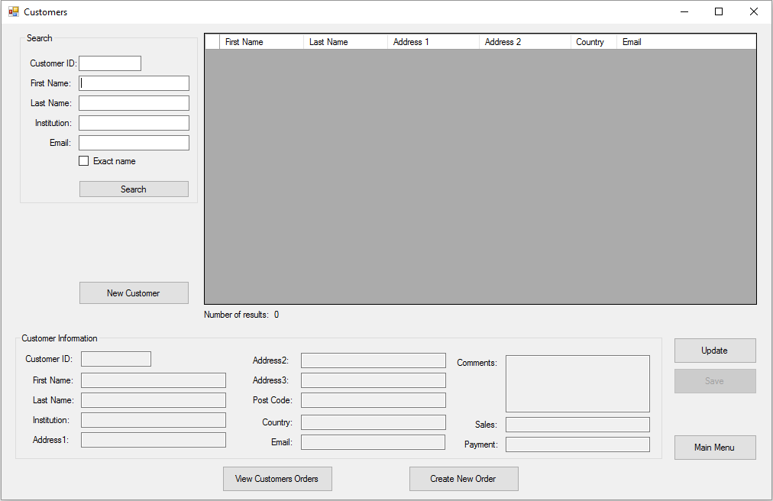

Here you can search for any customers that have been previously entered into the system. Update their information or enter in a new customer.

Customers can be searched by their ID, first name, last name, institution, and email. If an ID has been entered the system will use that to search on. If any other information has been entered it will search for a customer that matches all the entered information.

The exact name box can be ticked to help narrow down results and eliminate problems such as searching for the name “Chris” and getting results including names such as “Christopher”. Ticking the box will make the system search for names containing the exact name entered.

When customers have been searched for, you can select their name from the list and their details will be filled into the boxes below. Once entered you can update the users information using the update and save button on the right.

While a customer is selected you can user the two buttons at the bottom of the screen to view any orders the customer has made or create a new order for the selected customer.

Double clicking on a customers name while in the list will bring up the customers order history also.

Once a search has been completed and found results, focus will shift to the list so it can be navigated with the arrow keys and enter can be pressed to move to the customers order history.

**Customers Orders:**

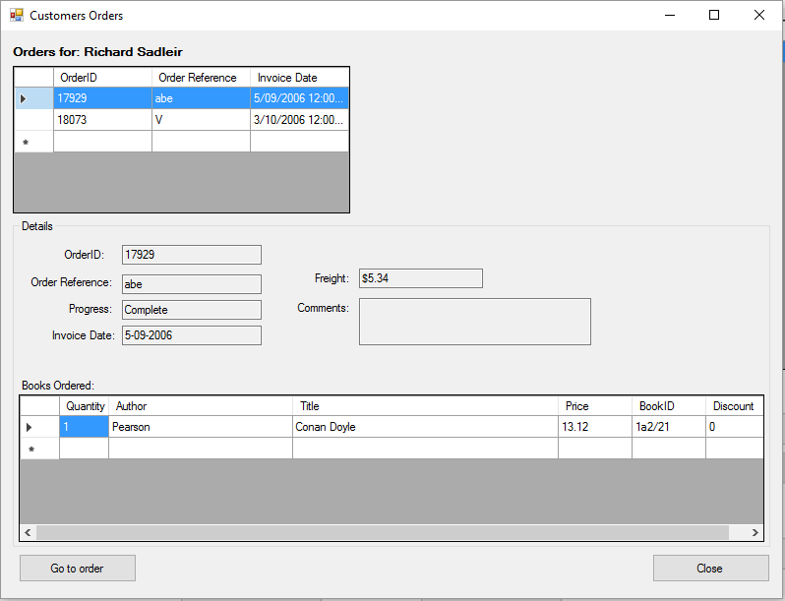

Here you can view the order history for a customer.

The list at the top of the screen is each of the orders the customer has made. Clicking on the orders there will update the rest of the screen with details of that order.

From this screen you can click the “Go to order” button in the bottom right to view the full order and update any information on the order if needed.

**Stock Screen:**

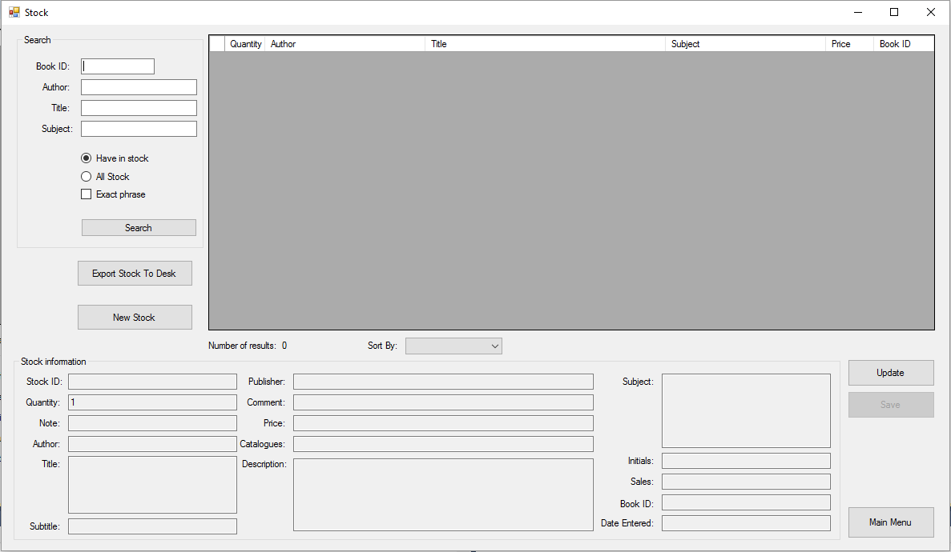

From this screen you can search for any stock that has been entered into the system.

Stock can be searched by their BookID, author, title, and subject. If a book is searched by its BookID that will be the only information searched on. If any other information is entered it will try find a book matching all of the entered information.

An author can be searched by their first and last name entered in any order, separated by a space. Books that have multiple orders can be searched by typing in both author names or any combination of their first and last names, as long as they are separated by spaces.

Titles can be searched by two methods:

* Typing in key words from the title. E.g the book “The People Have Strength” can be found by typing “people strength”
* Typing in a section of the books title E.g “The people have” will still find the book “The People Have Strength”

Only a single subject can be searched for at a time, but this can be combined with authors and titles to narrow down search results.

The buttons below the search text boxes can be used to select whether the search incluces books that have their quantities set to 0 or not.

After a search has been completed, focus will shift over to the list so it can be navigated with arrow keys.

Search results can be sorted using the drop down menu below the list of search results. The results can be sorted by the number of books in stock, alphabetically by author and title or by price.

After stock has been searched you can select the stock from the list and it’s details will automatically be filled into the fields below.

Once stock has been selected you can update it’s details using the “Update” and “Save” Buttons to the right of the screen.

The “Export Stock To Desk” button will allow to you send stock to the store front system to update it. It will prompt you for an amount of stock that the previous system need to be updated by. You will need to give it the amount of books that has been entered on the main system and not the store front system to properly update the store front system. There won’t be any issues if you give it a number over what has been entered on the main system so the default is set to a reasonably high number of 500.

New Stock can be entered by clicking the “New Stock” button where you will be prompted with a new screen for entering stock.

**New Stock Screen:**

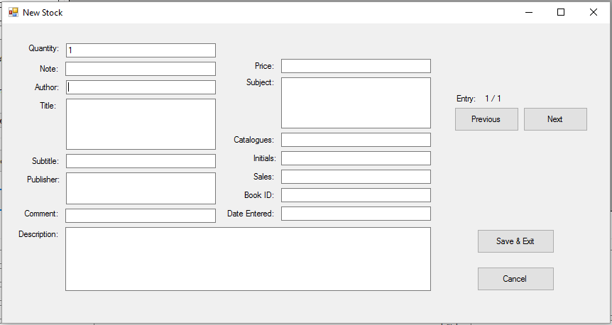

Here you can enter new books into the system.

You can view the most recently entered books into the system by pressing the “Previous” button or the shortcut key “Ctrl + ,”. This will allow you to get the latest book IDs. While the Entry counter in the top right reads 0 or a negative number, changes won’t be saved to the system.

To move to the next entry or to create a new entry click the “Next” button or use the shortcut key “Ctrl + .”

The fields can be autofilled in with what the previous entry had entered by pressing Ctrl + ‘

Price will automatically have the $ and turned into 2 decimal places if not already added when the price field is exited.

When all the books you want to have entered are finished you can click the “Save & Exit” button to enter them into the system.

**For the store front system:**

The new stock that has been entered will remain in “New Stock” menu until the data has been exported.

**Orders Screen:**

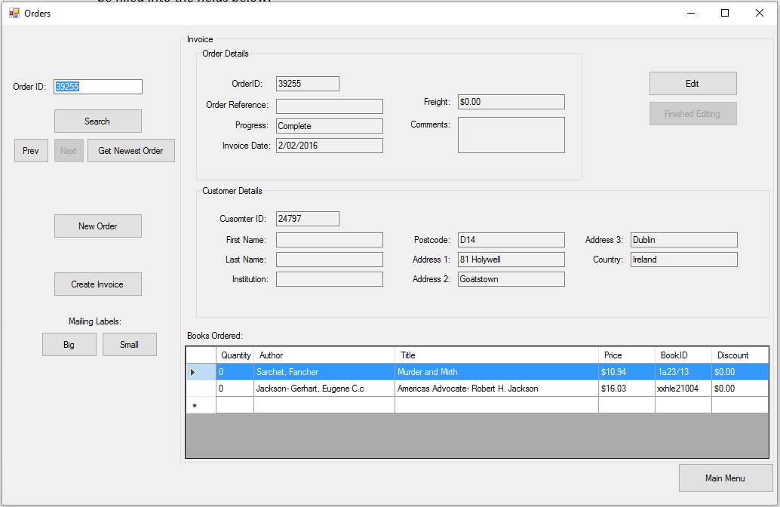

Here you can view all of the orders that have been entered into the system. You search for orders, update, enter new orders, create invoices and mailing labels for selected orders.

By default the last order entered into the system is loaded up. Orders can be navigated by using the “Prev” and “Next” buttons to flick between orders.

Orders can also be found using the search function if you know the OrderID/Invoice Number by entering it into the text field provided in the top left and clicking the search button or pressing enter while still in the text box.

Orders can be updated using the “Edit” and “Finished Editing” buttons in the top right. When the edit button is pressed it unlocks the text boxes so they can be typed in. A new button appears to change the customer if needed. Another button also appears to add more books onto the order. The list of books ordered at the bottom of the screen can also have books removed from the order by right clicking on them.

**New Order Screen:**

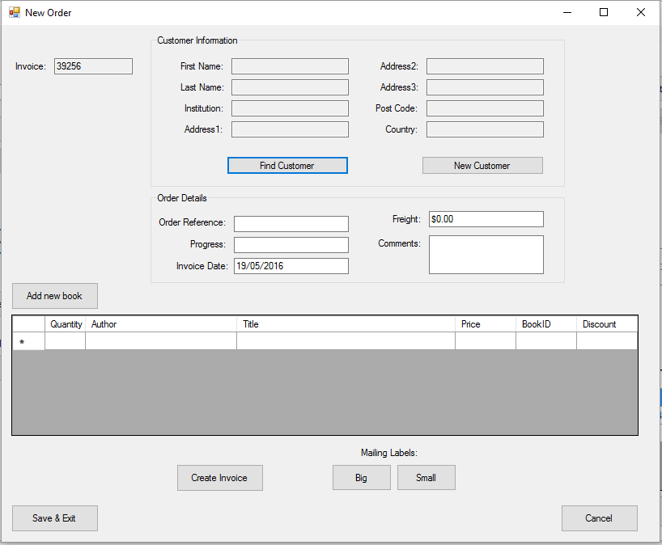

This screen is accessed through the Orders Screen. Here you can enter a new order into the system.

Existing customers can be added onto the order by clicking the “Find Customer” button and doing a search that works the same as the Customers Screen searching shown previously.

Or if you are entering an order for a new customer you can click the “New Customer” button and enter in all of the details of the customer. The customer will be saved into the system and their details will be filled in on the order.

New books can be added onto the order by clicking the “Add new book” button. A new screen will pop up where you can search for stock. The searching works the same as the previously shown Stock Screen.

Once a book has been selected it’s details will be entered into the list and can be edited as needed. If a wrong book is selected you can right click to remove the book.

Invoices and labels can also be created for the order from here.

The order is only saved into the system once the “Save & Exit” button has been clicked.

**Reports:**

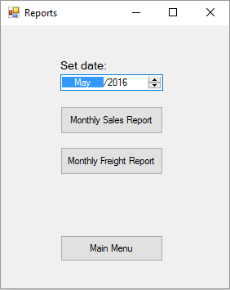

Here you can create monthly reports and freight reports.

Start by selecting the month and year you want a report from using the selector near the top of the screen.

After the desired month has been selected clicking the buttons will produce a report in a Microsoft Word document and open it automatically.

Monthly sales reports will show all of the orders for a given month and which country they were ordered from. It will sum up all of the orders price as a total at the end of the document.

The freight report will provide the date, invoice number, country and freight cost for the orders. It will provide a total at the end for the amount spent on shipping.

**File Exports:**

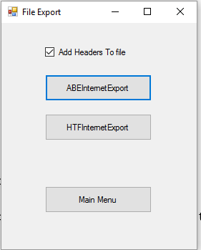

This screen is used to create the exports to update the stock displayed on the various websites. The location the files will be stored is set in the setup menu. After a file has been created it will tell you the storage location of the file.

The checkbox “Add Header To file” is used to add an extra line to the CSV file for what each of the columns is. This is used for the TurboWeb website upload.

**Imports Screen:**

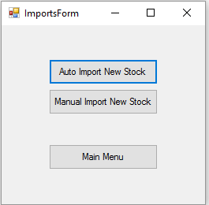

This screen is used to update the stock information when it has been entered on the store front system.

The location that the system updates from is set in the Setup menu.

Auto Import will look for all files in the set location that contain the word “Stock” in its filename, and pull all of the information out of it to enter into the system. Once completed the system will delete the file so it doesn’t get duplicated in the system.

Manual Import can be used to manually select the files you want to import from. They must contain the word “Stock” in the filename and be formatted as a CSV:

StockID|Quantity|Note|Author|Title|Subtitle|Publisher|Description|Comment|Location|Price|Subject|Catalogues|Weight|Sales|BookID|EnteredBy

**Backup Screen:**

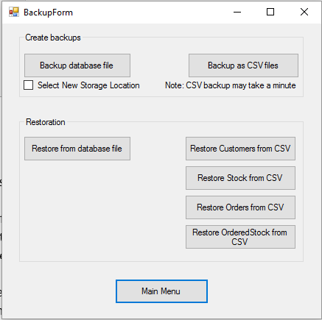

This screen will allow easy backup of the database. The database is stored in the same directory as the rest of the program. The file is named HardToFindDB.sqlite.

To create a backup of the file, click the “Backup database file” button to do a backup automatically. Click the checkbox labeled “Select New Storage Location” if you wish to change the location the file is being backed up to.

“Backup as CSV files” is futureproofing incase the data ever needs to be extracted from the database in an easy to use format.

To restore the database file, click the “Restore from database file” button. The window will automatically open up to where the storage location for backups is set, you can then select the file named with the date you want to back up from.

Restoring the database from the CSV files can also be done if you have backed up from CSV files. Do this by clicking each of the buttons for the different things the database stores and then clicking on the backed up CSV file with the same name as what is on the button.

**Store Front System:**

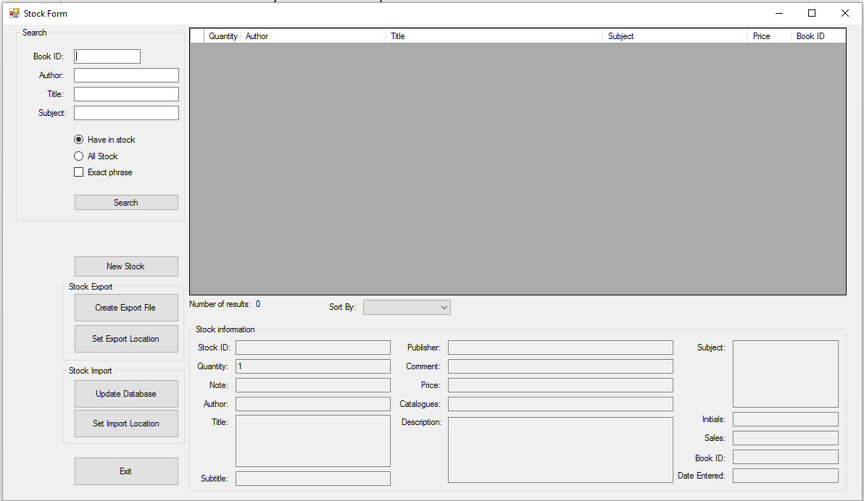

Most of the functionality on this screen is the same as the “Stock Screen” refer to that for more details about how this page works.

Entering stock works mostly the same as the main system except the data remains in the New Stock Screen until the data has been exported.

First time running this program or if you need to change the locations you need to click the “Set Export Location” button and the “Set Import Location” button. Importing is used to update the data from the main system. Exporting is used to update the main system with the data entered on this system.

The locations of the import and export should be set to the two different folders located in the Google Drive to allow for easy transfer of data without using USB flash drives.

Theses folders if already set up should be located in:

C:\Users\(UserName)\Google Drive

(UserName) is a stand in for what the current logged in user has their username set to.

Information for setting up the Google Drive can be found below.

**Google Drive Setup:**

First go to [www.google.com](http://www.google.com)

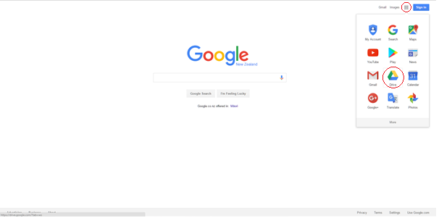

Click the grid in the top right corner to bring up the menu where you will find the button labeled “Drive” and then click that.

On the following screen click the “Go to Google Drive” button.

Then log in with the stores set up email address.

Once inside click on the “Get Drive for PC” button in the bottom left.

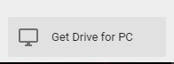

Then on the screen that it opens up click the “Download for PC” button

Click accept & install when prompted.

Once the download has been completed it can be found at the bottom of your browser. Highlighted in red in the picture below.

Click on the download to install.

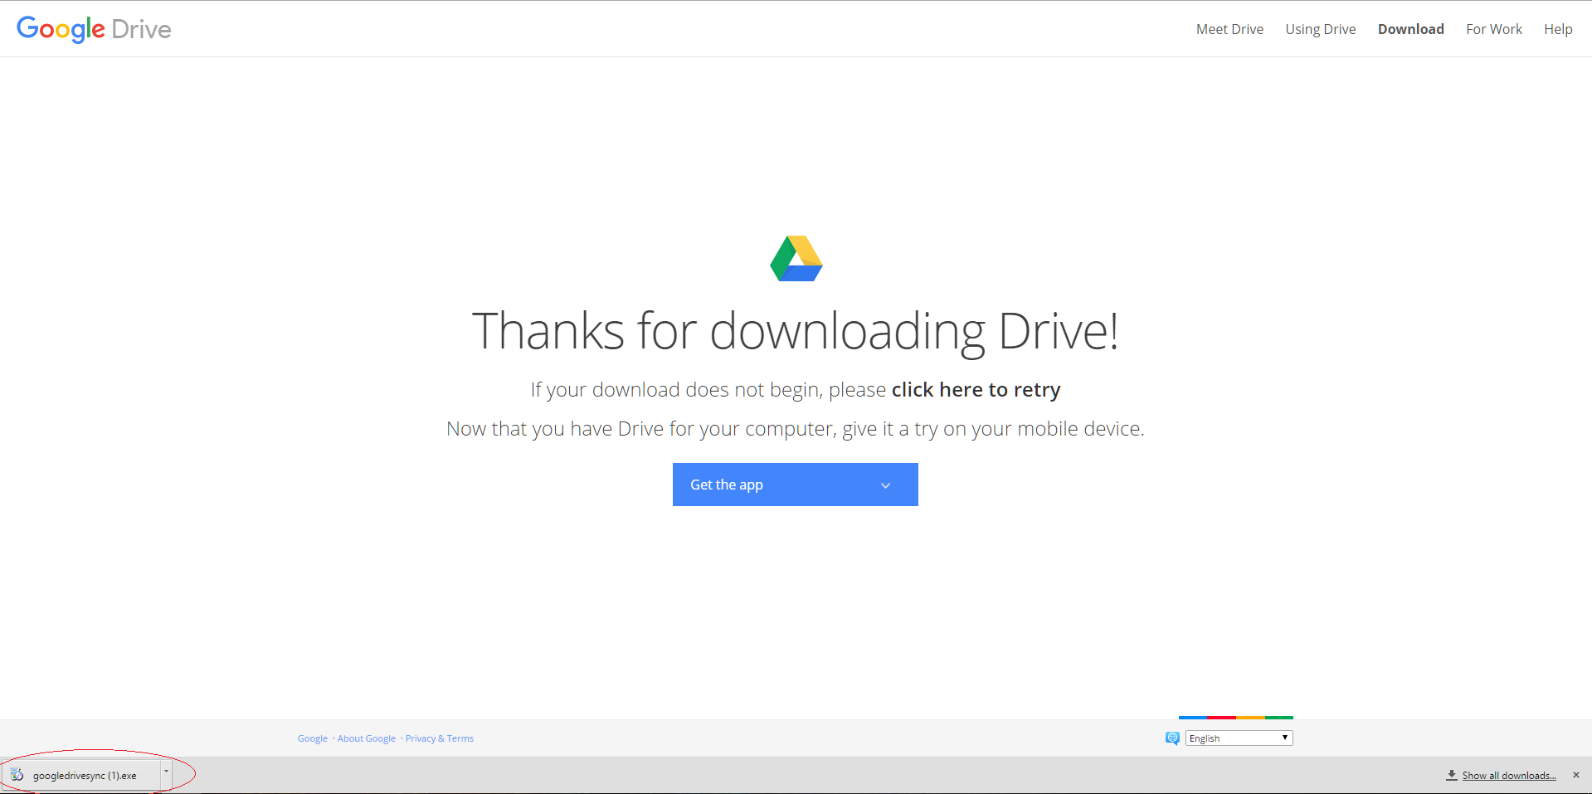

Follow through the install process until completed.

Once installed an icon will be placed on your Desktop labeled “Google Drive”



Open that and create two folders inside. One for importing stock into the main system and one for exporting stock to the store front system to update it.

During setup in the setup menu after clicking the “Set Import Location” and “Set Export Location” to find these folders in the following menu after the buttons are pressed, navigate to the location: C:\Users\(UserName)\Google Drive

(UserName) is a stand in for what the current logged in user has their username set to.

**Troubleshooting:**

If Google Drive isn’t transferring the file between the systems but it the file can still be found in the “Google Drive” folder on the desktop.

Check to see if the file has a tick or swirling arrows on the icon E.g



Then Google Drive isn’t running in the background. To fix this click on the start menu and type in “google drive”. Once Google Drive has been location click on it and it should start running again in the background and sync the files.

If there are any additional troubles or if information is required you can contact:  
Cameron Hill:

Ph: 027 3731367

Email: c.g.hill46@gmail.com